Vicente Telles
Primera Voz/ First Voice, 2026
Material Watercolour pigments, foraged micaceous clay, oil pastel, soft pastel, masonite panel, T-shirt, bean sack, split logs
Courtesy of the artist
Copyright © Vicente Telles

Commissioned by the Biennale of Sydney with generous support from Campbelltown Arts

Education Resource (7-12)

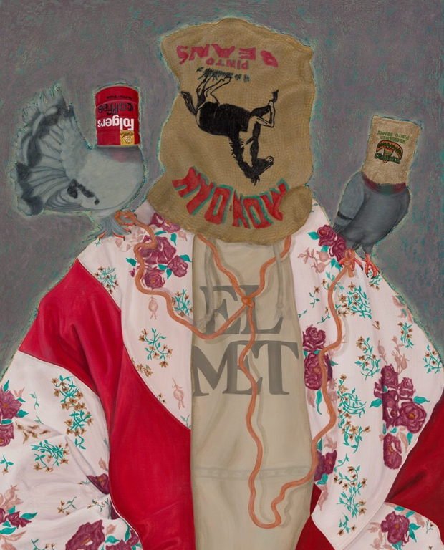
El Met (from the Cobijas de Mis Madres - Blankets of my Mothers series), 2023
Commissioned by AltaMed Art Collection.
Photograph: Carr Imaging.
Courtesy of the artist

Overview

Primera Voz / First Voice is a profound exploration of language, identity, and the art of erasure. Developed during a residency at Campbelltown Arts Centre, the work reflects Telles’s upbringing in Albuquerque, New Mexico, where forced assimilation led to the suppression of his first language, Spanish. Telles conceptualises this loss as a "shadow" that lingers behind the necessity of English, representing a disconnect from his ancestral roots and a "double estrangement" from the dominant culture that enforced this silence.
Telles identifies as a Santero (maker of saints) and Cultural Iconographer, bridging the gap between traditional religious art and contemporary social commentary. In this work, his materiality is conceptual; he utilises the visual language of the santero tradition—historically used for devotion and preservation—to document the modern socio-political erasure of his community. By adopting these traditional forms, he embeds memory, voice, and identity into the very structure of the piece, reclaiming a medium that was once purely liturgical to speak on contemporary survival.
This artwork demonstrates how the choice of medium and tradition reinforces meaning. The layering of iconographic symbols connects Telles’ personal history to broader global conversations about colonisation, settler violence, and the resilience of minoritised cultures. Ultimately, Primera Voz asserts that heritage is not static, but alive and evolving, using the weight of historical form to reclaim a voice that was once silenced.

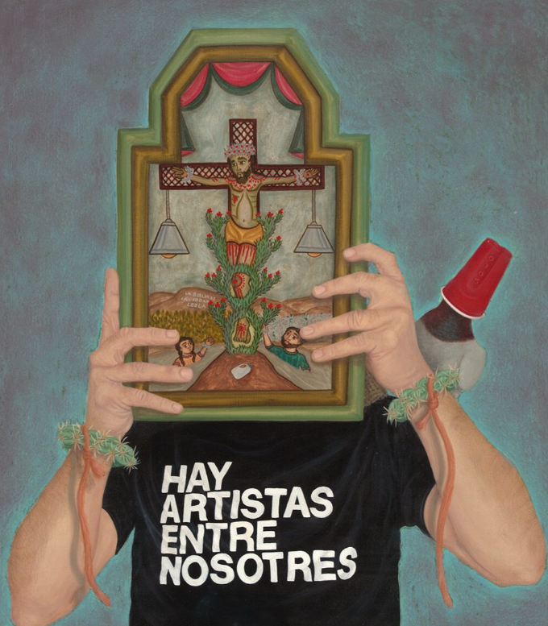

Hay Artistas, 2025,
Commissioned by Nuevo Mexicano Heritage Arts Museum.
Photograph: Carr Imaging.
Courtesy of the artist

Discussion Questions

Telles does not use store-bought paint; he forages for micaceous clay and mineral pigments in New Mexico to make his own.
How does using the land itself as a medium change the way you interpret the artwork?
How might a painting exist an extension of Country rather than just a representation of it?
What specific material could you use that physically contains the history of your concept (e.g., using soil, fabric from home, or recycled text)?
Telles describes his lost native language (Spanish) as a shadow, while English became a necessity. Visually, where do you see this tension between what is visible (the necessity) and what is hidden or erased (the shadow) in the composition?
How does Telles use layering or erasure to show a psychological feeling of loss?
Practical Activities
Activity 1

Turn your paper horizontally. Very lightly (barely visible), write a phrase or a series of words across the page that relates to your own first voice.
This could be your family name, a phrase from your home language, or a personal belief.
Look at the composition of Primera Voz. Notice the large forms or blocks of color that Telles uses.
Using the side of your pencil lead, draw these shapes directly over your written words.
Press hard to represent the dominant culture or necessity.
Press lightly to represent the shadows.
Your goal is to obscure your original words, so they are mostly unreadable, leaving only fragments visible through the pencil shading.
Does the First Voice underneath look like it is disappearing, or does it look like it is holding the structure up?
This mirrors Telles' exploration of how a suppressed language produces a sense of displacement yet remains as a foundation

Activity 2
Stand back and scan the painting from left to right. Imagine the canvas is a timeline of sound or music.
At the bottom of your paper, invent three abstract symbols to represent the sounds of Telles' materials:
The Land (Micaceous Clay): What does the rough, foraged earth sound like? (e.g., Static? A low hum? A drum beat?). Draw a mark for this.
The Erasure (Smooth Paint): What does the assimilation sound like? (e.g., Sudden silence? A sharp high-pitch tone?). Draw a mark for this.
The Shadow (Lingering Spanish): What does the shadow language sound like? (e.g., A whisper? A glitch?). Draw a mark for this.
Compose the score using your symbols across the page.
For example:
If the painting has a large block of rough clay on the left, your score should start with heavy static.
If it fades into a smooth area, your score should drop to silence.
Disrupt the rhythm where you see the shadows appearing.
You should end up with a visual sound wave that maps the intensity of Telle’s voice versus the silence of erasure.

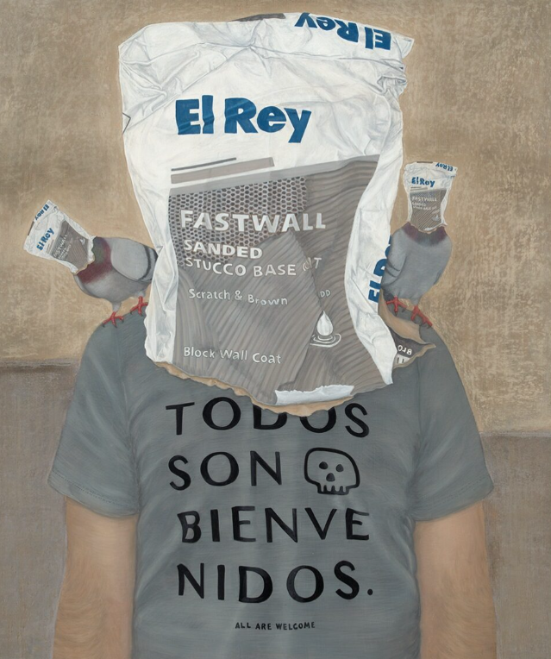

Los Tres Reyes, 2022,
Commissioned by Elyse & Emilio Gonzales.
Photograph: Carr Imaging.
Courtesy of the artist

