Vicente Telles
Primera Voz/ First Voice, 2026
material Watercolour pigments, foraged micaceous clay, oil pastel, soft pastel, masonite panel, T-shirt, bean sack, split logs
Courtesy of the artist
Copyright © Vicente Telles

Commissioned by the Biennale of Sydney with generous support from Campbelltown Arts

Education Resource (K-6)
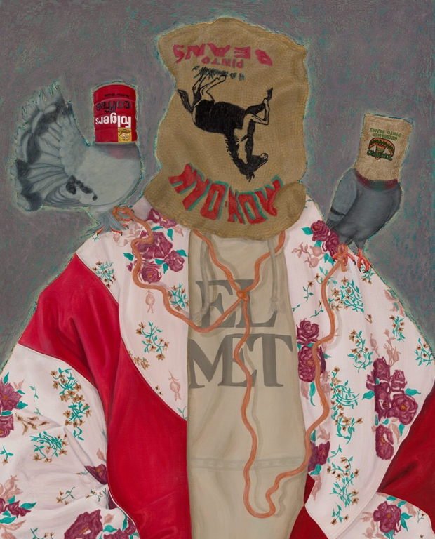
El Met (from the Cobijas de Mis Madres - Blankets of my Mothers series), 2023
Commissioned by AltaMed Art Collection.
Photograph: Carr Imaging.
Courtesy of the artist

Overview

Vicente Telles is an artist from New Mexico who describes himself as a Cultural Iconographer. That might sound like a complicated title, but it has a beautiful meaning: he paints pictures to save the history, traditions, and spirit of his family so they are never forgotten. He believes that art is a way to keep the past alive.
One of the most important stories he wants to share is right here in this painting, titled Primera Voz (which translates to "First Voice"). It tells a personal story of Vicente’s childhood. Growing up, Vicente’s family spoke Spanish. However, in his community, people were often forced to stop speaking their home language and speak only English. Vicente felt that losing his first voice was like losing a piece of himself. He says that Spanish became like a shadow — always there but hidden away. He created this artwork to show that our languages are special gifts from our ancestors that help tell us who we are.
Vicente paints using symbols, such as special shapes and figures, that he hides in his work. When you look at the painting, can you see any symbols that look like they are telling a secret story? By painting this way, Vicente is making sure his "First Voice" is finally being heard loud and clear.

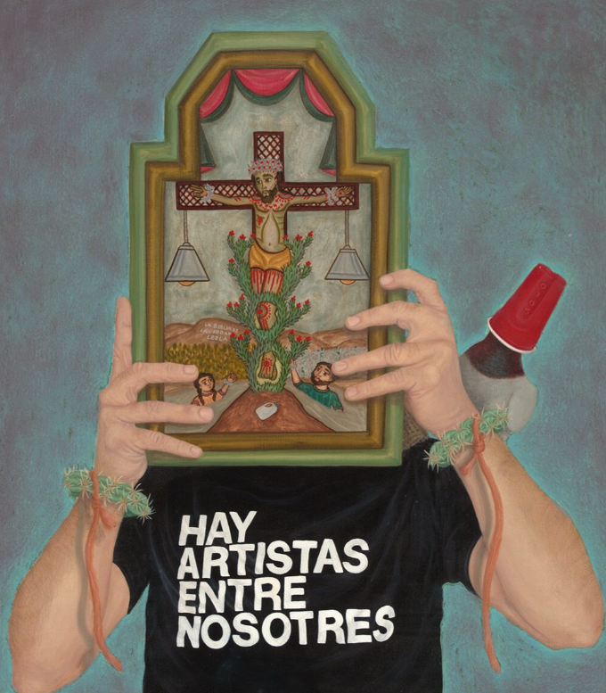

Hay Artistas, 2025,
Commissioned by Nuevo Mexicano Heritage Arts Museum.
Photograph: Carr Imaging. Courtesy of the artist

Discussion Questions

Instead of just buying paint from a shop, Vicente uses clay and rocks from the ground near his home to make his colours.
What colours from nature do they remind you of?
How does this artwork make you feel? Why does it make you feel that way?
Vicente calls this painting First Voice. If this painting could speak, what do you think it would say?
Do you speak a different language at home than you do at school? How does speaking that language make you feel?

Practical Activities
Activity 1

Before you pick up your pencil, stand in front of the painting for 30 seconds and just look. Don't say anything yet.
Vicente hid secret shapes and symbols inside this painting — your job is to find them, like a detective.
Now look closely at the whole painting.
On your paper, sketch three shapes or symbols you can spot hiding somewhere in the artwork. They don't need to be perfect, quick sketches are fine.
When you've drawn your three, circle the one that feels most interesting or mysterious to you.
Now write one sentence underneath: "I think Vicente hid this shape because..."

Activity 2
Primera Voz, which means First Voice. Vicente made this painting because he felt that losing his first language, Spanish, was like losing a piece of himself. He said it became like a shadow — always there, but hidden away.
On your paper, draw a large speech bubble.
Inside it, write a word or phrase from a language that feels like home to you — it might be a language you speak with your family, a word a grandparent uses, or even just a sound that feels familiar and warm. If you can, write what it means underneath.
Now outside the speech bubble, write or draw your answer to this:
"How does it feel when you get to use that word or language — and how does it feel when you can't?"
Look back at the painting while you think.
Can you see that feeling somewhere in Vicente's work?

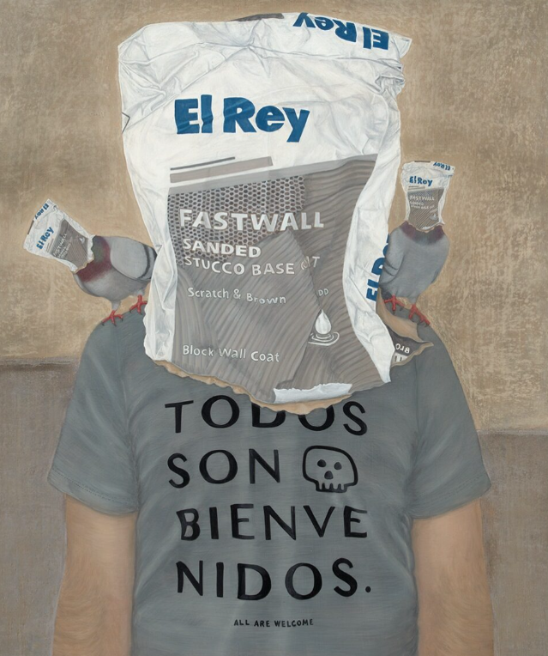

Los Tres Reyes, 2022,
Commissioned by Elyse & Emilio Gonzales.
Photograph: Carr Imaging.
Courtesy of the artist

