Sandra Monterosso
The Zig Zag of the Mountain 2024-25
from the series Recipes for healing wounds
embroidered fabric prints, linen, cotton and natural fibre dyed with indigo, tumeric, cochinial, chamomile, annato and synthetic dye

Commissioned by the Biennale of Sydney
Courtesy of the artist and NG Art Gallery

Education Resource (7-12)
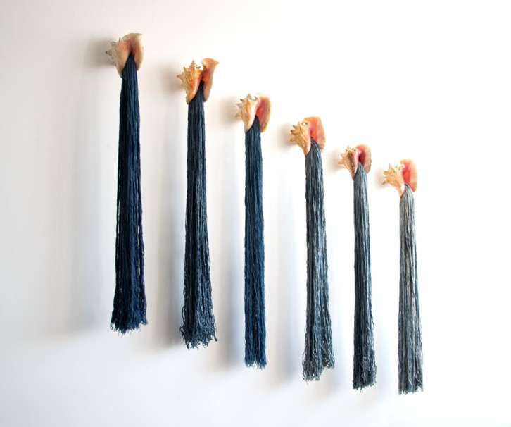
Hilos de agua y caracol. (Threads of water and snail) from the series Ofrendas (Offerings)
Installation view at Sandra Monterroso studio, 2023, Textile art.
Six sea snails, Indigofera-dyed yarn, resin. 175x 170 x 16 cm.
Photograph: Isabella Monterroso.
Courtesy of the artist ©Sandra Monterroso

Overview
Healing a community can be a slow, rhythmic process, much like the act of weaving or the patient growth of a plant. This monumental textile installation by Sandra Monterroso functions as a living archive and a textile recipe book designed to mend both personal and collective histories. For Monterroso, an artist of Maya Q’eqchi’ descent, the physical work of dyeing and sewing is a metaphor for healing colonial wounds — recovering the ancestral knowledge and Indigenous practices that were historically suppressed.
The structure of the work is inspired by the geometric, origami-like layers of a mountain and a 1978 book detailing popular Mayan medicine. The five panels are hand-dyed using organic pigments found in the earth: deep blue from indigofera, bright red from cochineal insects, and golden yellow from turmeric. Across these colours, you will find botanical drawings of animals and minerals used in healing, which the artist created by blending her own cultural knowledge with scientific libraries and modern AI tools.
This project is built on the belief that art is a shared responsibility. The mural was originally activated through a workshop where volunteers from the LGBTQ+ community shared medicinal recipes and helped embroider the figures onto the fabric. By collaborating with groups that have often been marginalised or silenced, Monterroso ensures that her art remains a living practice of community care. Her work teaches us that when we gather to protect nature and share our diverse stories, we participate in a powerful cycle of preservation and healing.

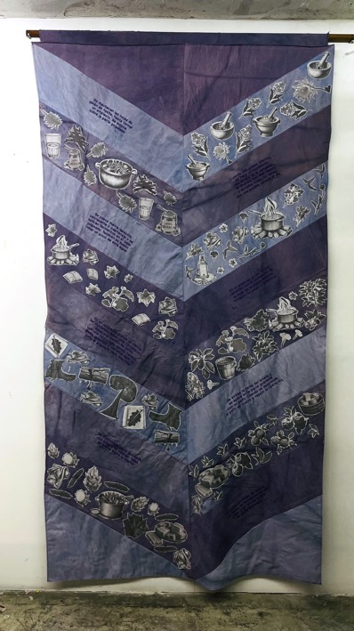 | 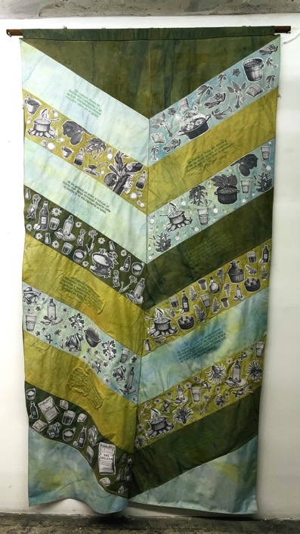

El zig zag de la montana modulo Morado (left)
El zig zag de la montana modulo Verde (right)

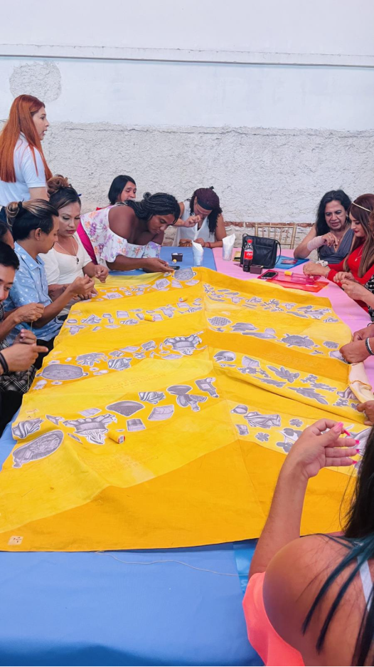

Activation of workshop
Courtesy of the artist ©Sandra Monterroso

Discussion Questions

The materials and methods used to create this Monterroso’s work are deeply connected to its meaning.
How does the slow, rhythmic act of weaving physically represent the mending of a community?
Why do you think Monterroso chose organic, earth-based dyes like indigo and turmeric instead of regular synthetic paints?
Monterroso’s installation is not just a picture to look at; it is designed to actively hold and protect important cultural and botanical information.
What does it mean for a monumental textile installation to function as a living archive or a recipe book?
In what ways does blending Mayan botanical knowledge with artificial intelligence change how we look at history?
Monterroso chose not to make this work alone, meaning the social relationships formed during its creation are a vital part of the art itself.
Why is it conceptually significant that Monterroso invited volunteers from marginalised communities to physically help embroider onto the fabric?
How does sharing the manual labour of creating art transform a static object into an active practice of community care?

Practical Activities
Activity 1
Begin by selecting one specific, hand-dyed panel of the installation to observe closely.
Take a moment to analyse the organic pigment used to dye the fabric itself, identifying whether the deep blue indigo, bright red cochineal, or golden yellow turmeric forms the foundational landscape of your chosen section.
Once you have documented this background colour in your visual arts diary, shift your focus to the surface and choose one specific botanical, animal, or mineral figure that has been embroidered or drawn onto that dyed textile.
Spend five to ten minutes creating a continuous line drawing of your chosen figure, focusing purely on capturing its intricate shape and form without lifting your pen from the paper.
After completing your sketch, write a short analytical paragraph hypothesising the conceptual relationship between the figure you drew and the specific earth-based dye of the fabric it sits upon.
Consider why Monterroso might have chosen to place that specific healing symbol on that grounding colour, and how the organically dyed textile acts as a physical landscape for the ancestral knowledge recorded over it.

Activity 2
Find a quiet place to sit in front of the artwork and reflect on its function as a textile recipe book built through active community collaboration.
Begin by writing down a short, paragraph-length 'recipe' in your visual arts diary for healing a community issue you care deeply about.
You must clearly list metaphorical ingredients inspired by the installation's themes, such as patience, active listening, ancestral knowledge, or shared labour.
Next, translate your written recipe into a visual language by designing a single, simple symbol or motif that represents your healing concept.
Sketch this motif in your diary as if you were preparing to embroider it directly onto the final panel of Monterroso's installation, carefully considering the scale and thick line weight that would be required for actual needlework.
Finally, add a brief annotation detailing which of the three organic, earth-based dye colours you would choose as the background fabric for your embroidered symbol, justifying how that specific colour enhances the meaning of your community care recipe.

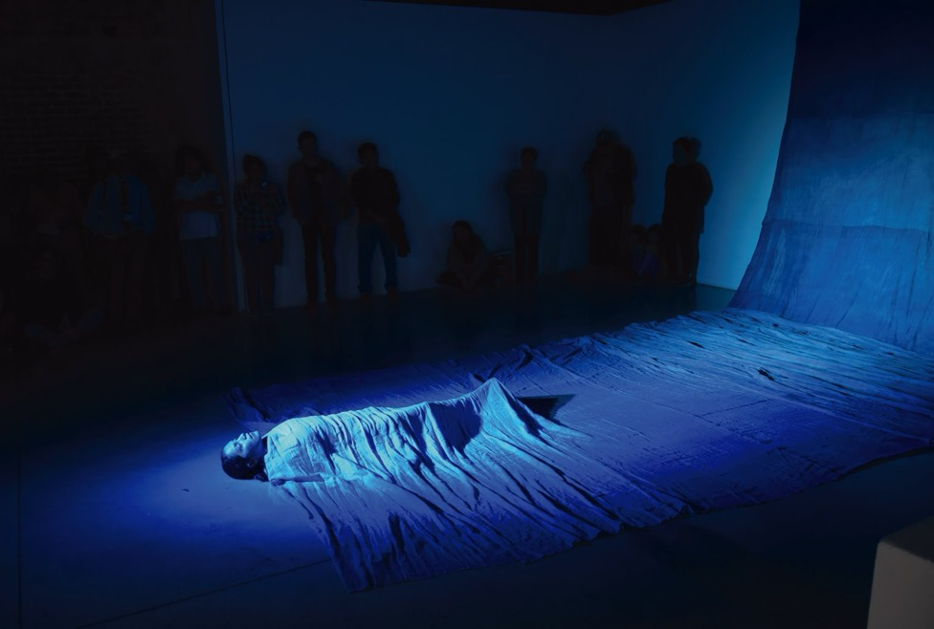El agua se volvió oro, el rio se volvió oro, el oro se volvió azul. The water turned to gold, the river turned to gold, the gold turned to blue from the series Las Heridas También Pueden Teñirse de Azul.
Wounds can also be dyed in blue.
2019, Installation,performance, 17 x 3 m
Photograph: Isabella Monterroso.
Courtesy of the artist ©Sandra Monterroso

