Sandra Monterosso
The Zig Zag of the Mountain 2024-25
from the series Recipes for healing wounds
embroidered fabric prints, linen, cotton and natural fibre dyed with indigo, tumeric, cochinial, chamomile, annato and synthetic dye

Commissioned by the Biennale of Sydney
Courtesy of the artist and NG Art Gallery

Education Resource (K-6)
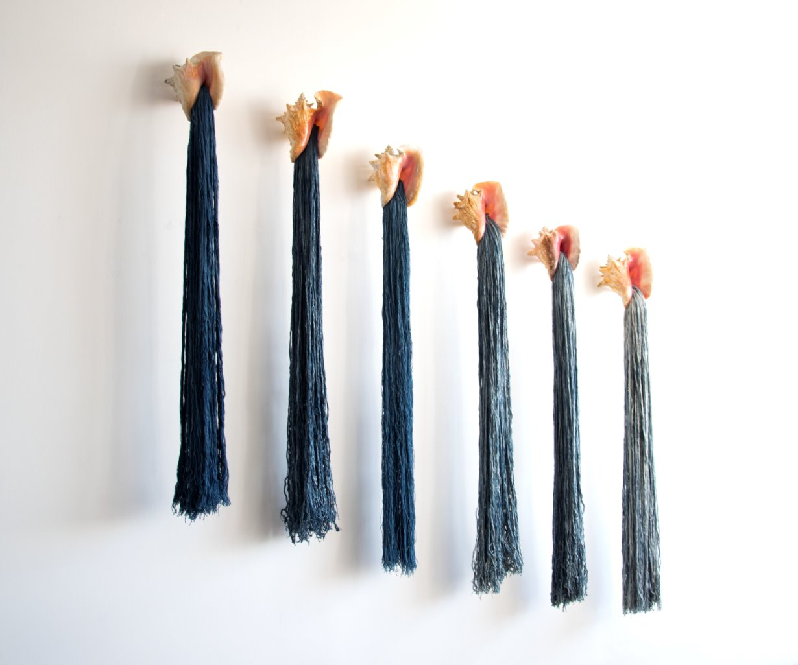
Hilos de agua y caracol. (Threads of water and snail) from the series Ofrendas (Offerings)
Installation view at Sandra Monterroso studio, 2023, Textile art.
Six sea snails, Indigofera-dyed yarn, resin. 175x 170 x 16 cm.
Photograph: Isabella Monterroso.
Courtesy of the artist ©Sandra Monterroso

Overview
Have you ever wondered if a piece of cloth could hold a secret recipe for making the world feel better? The artist Sandra Monterroso, who is proud of her Maya Q’eqchi’ heritage, created this giant artwork called The Zig Zag of the Mountain to do exactly that. Monumental in scale, this artwork is a five-panel textile mural that looks just like the geometric layers of an origami mountain.
Sandra used linen, cotton, and dyes made straight from the earth, like bright red from tiny bugs, deep blue from plants, and golden yellow from spices. Using colours straight from nature is like holding hands with the past, showing that her ancestors' traditions are alive and growing today.
If you look closely at the colorful layers, you will spot careful drawings of plants, animals, and stones that have been printed on fabric and sewn onto the coloured panels. These images are the ingredients of the healing recipes from an old book about medicines from her ancestors. Sandra combined her own knowledge of nature with science libraries and the computer to create these pictures.
An integral element to this this artwork is that Sandra didn’t make it alone. She invited a group of volunteers to a special workshop to share these healing recipes and care for one another. By gathering the whole community to create art together, Sandra turned her work into a safe space where everyone belongs.

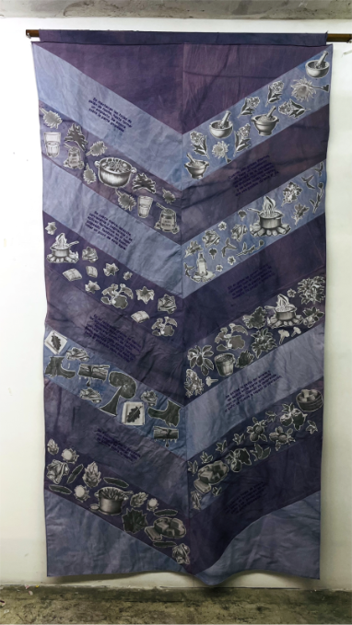 | 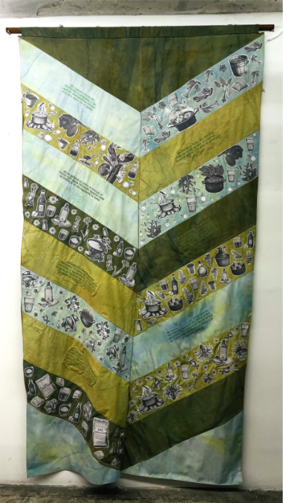

El zig zag de la montana modulo Morado (left)
El zig zag de la montana modulo Verde (right)

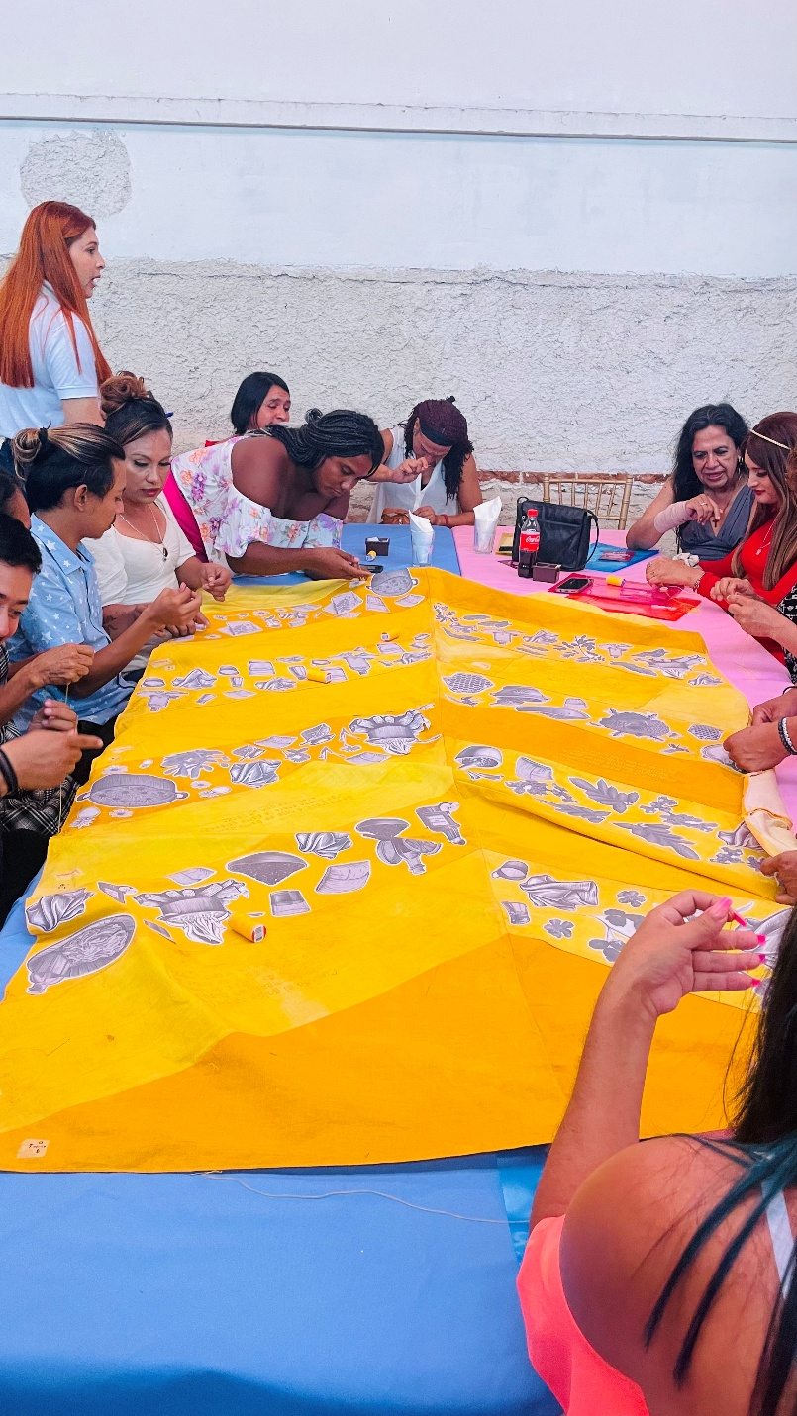

Activation of workshop
Courtesy of the artist ©Sandra Monterroso

Discussion Questions
By observing Sandra’s giant textiles closely, you can discover hidden textures and shapes that tell a story.
What is the very first thing you see when you stand in front of this giant cloth mountain? If you step really close to the fabric, what kind of textures, lines, or shapes can you find hiding in the layers? Take a careful look around the different colours and see if you can spot any drawings of plants, animals, or stones stitched into the cloth.
Sandra uses materials from the earth to share a story about medicine and memory.
Why do you think Sandra decided to paint using colours made from crushed bugs, roots, and spices instead of just buying normal paint from a store?
When you see how the fabric is folded and layered across the wall, does it remind you more of a mountain, a map, or the pages of a very old recipe book?
Practical Activities
Activity 1
For this activity, you will need a blank piece of paper, pencils, and some coloured pencils that remind you of the earth, like deep blues, bright reds, or golden yellows.
Imagine that Sandra has sent you a blank square of fabric and asked you to add your very own healing design to The Zig Zag of the Mountain.
Close your eyes and think about a plant, animal, or special symbol that makes you feel safe, strong, or cared for.
Once you have your idea, draw it right in the centre of your paper, making it as detailed as you can so it looks like the botanical drawings in the artwork.
After you finish your drawing, think about the colours you chose and where they come from in nature, just like the blue, red, and yellow Sandra uses.
On the bottom of your paper, write a short story or a few sentences explaining why you chose this specific symbol to help heal your community.
Take some time to write down how you think using colours that come straight from the dirt, plants, and insects helps us hold hands with the past.
Share your drawing and your story with a classmate.

Activity 2
For this activity, you will need a piece of paper and a pencil.
Stand in front of the mural, look closely at the botanical drawings, and find one specific leaf, bug, or animal that catches your eye.
Notice how the lines of thread sit on top of the cloth to build those shapes. This is embroidery; a slow, careful way of drawing with thread that requires patience.
Instead of using a needle and thread, you are going to use your pencil to create paper stitches right here in the exhibition. Try drawing the shape you chose by only making small, careful marks on your paper,
like short dashes, tiny crosses, or little zig zag lines. Try not to use any long, continuous lines.
Imagine that every single mark of your pencil is a piece of coloured thread pulling tightly through the fabric.
As you slowly build your picture, think about how it feels to make art one tiny stitch at a time, just like the community of volunteers who sat together to carefully sew their shared history into the mountain.

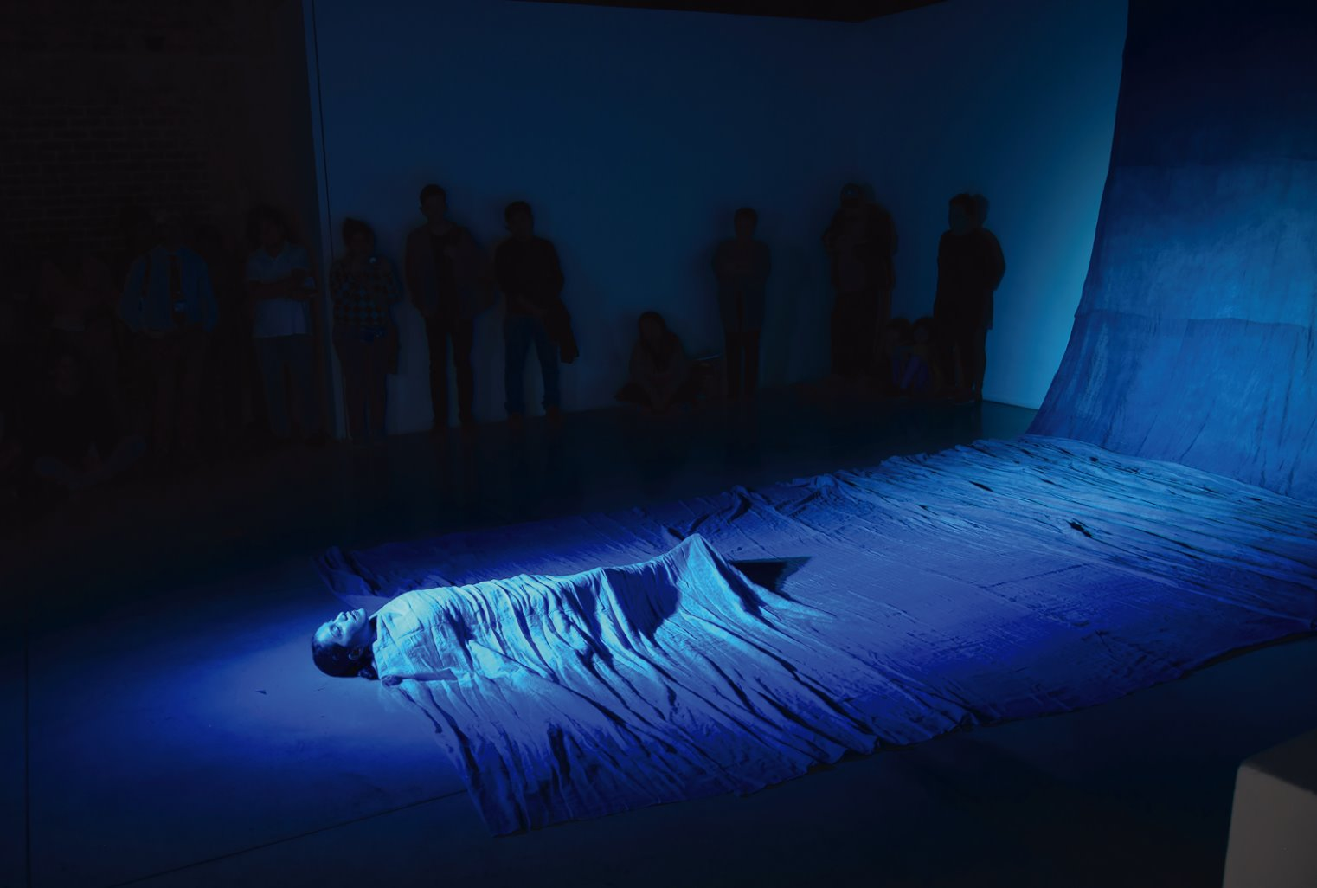El agua se volvió oro, el rio se volvió oro, el oro se volvió azul. The water turned to gold, the river turned to gold, the gold turned to blue from the series Las Heridas También Pueden Teñirse de Azul.
Wounds can also be dyed in blue.
2019, Installation,performance, 17 x 3 m
Photograph: Isabella Monterroso.
Courtesy of the artist ©Sandra Monterroso

