Nasri Sayegh
Les Yeux Sans Visage (Eyes without a face), 2025
polyester, digital sublimate on silk georgette
Retinæ – 1, Retinæ – 2, Retinæ – 3, Retinæ – 4, 2025
tapestry, wool and cotton
Stitch it, black!, 2025
needlepoint on aida cloth with needle, wool, cotton, lurex, high carbon steel
Courtesy of the artist
Copyright © Nasri Sayegh

Commissioned by the Biennale of Sydney and Rubaiya Qatar, Qatar Museums Authority with generous assistance from Australian Tapestry Workshop and Weaver, David Pearce.

Education Resource (7-12)
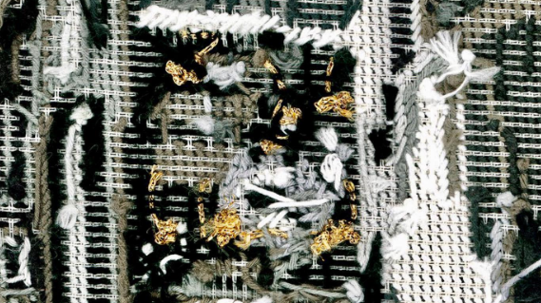
Memorial 1 / Fargo 1975, 2016
Photograph: Nasri Sayegh. Courtesy of the artist

Overview
Lebanese artist Nasri Sayegh transforms personal photographs into textile works that address the fragmentation of memory under sustained conflict. His practice combines collage, photography, and cross-stitch embroidery across multiple formats: delicate tapestries, a silk print and embroidery.
For Sayegh, the act of stitching is not merely a technique, but a form of emotional reparation. Created against the backdrop of conflict in Lebanon, the slow, repetitive rhythm of the needle becomes a way to process trauma. He treats the photograph not as a fixed historical document, but as raw material that can be deconstructed and rebuilt. Here, the digital pixel and the physical stitch act as parallel building blocks; both accumulate to form an image, yet one is instant while the other requires laborious time.
The installation challenges our ability to navigate these layers physically. The suspended silk georgette work, printed with watching eyes, refuses to be a static image. As you move around it, the fabric shifts and blurs, mimicking the instability of diasporic memory.
Ultimately, Sayegh reclaims embroidery as an urgent political practice. In a world where official histories often erase personal loss, these hand-stitched textiles act as a counter-archive. They do not attempt to hide the cracks in history; instead, they make the scars visible, suggesting that the only way to reconstruct the self after displacement is to piece it back together, one stitch at a time.

Je me souviens des montagnes, 2024
Photograph: Nasri Sayegh. Courtesy of the artist

Discussion Questions

Sayegh suggests memory, especially in the context of war and displacement, is never a complete image, but a collection of fragments held together by the labour of remembering.
Describe how Sayegh uses the stitch in his work, to rebuild the images. In your response consider if the threads seamlessly blend the images together, or do they sit on top like a scar?
How does Sayegh’s method change our understanding of healing?
How does this motif of the eye shift the role of the audience? Are we just observing the artwork, or is the artwork witnessing us? Explain.

Sayegh uses embroidery, a medium traditionally associated with domesticity and care, to document the violence of war. How does this contrast between the soft material (thread) and the hard subject matter (conflict/loss) affect your emotional response?
How does the embroidery allow Sayegh to take control of the story? What does this suggest about agency over our own identity?
Practical Activities

Activity 1
For this gallery activity, you will need your visual arts diary, a pencil or pen, a spare sheet of paper, an unfolded paperclip, and a length of yarn.
Taking a blank, thin piece of page and deliberately tear it into two distinct fragments. Allow the ragged, unpredictable edges of the tear to represent a fracture, perhaps symbolizing a broken memory or a sudden shift between two moments in time.
Position these torn pieces onto a fresh page in your diary, deliberately leaving a significant gap of negative space between them to emphasize the rupture.
You must now repair this gap physically sew the divide.
Carefully use the end of your paperclip to safely pierce small holes along the torn edges of your fragments. Then, thread your yarn through these holes, weaving across the empty space to physically bridge the gap and pull the torn pieces back toward one another.
If you prefer to draw, stick you torn paper onto a new place in your visual arts diary. Use your pencil or pen to invent a specific, repetitive mark that mimics the binding quality of thread, such as an aggressive cross-hatch, a continuous loop, or a jagged zigzag.
Whichever method you select, your focus should be on communicating the strain of this connection. Apply heavy pressure to your drawn lines or pull your yarn taut to demonstrate the tension and effort required to hold these fractured pieces together.
On a new page, write a brief reflection on the effect of your repair. Consider whether your stitches appear to hold the shapes together securely, or if the connection looks fragile and temporary, much like a wound that has not quite healed.

Activity 2

In your diary, draw a quick, realistic sketch of a single eye using a pencil. Observe Sayegh’s eye print as your reference. Take your time to notice the specific details of the iris, the weight of the lashes, and the way light reflects on the surface of the pupil.
Once the drawing is complete, your task is to intentionally disrupt it.
You are going to take this unbroken image and subject it to interference, visually representing Sayegh’s concept that memory is not a smooth, continuous film, but rather a series of fragmented moments that often do not align perfectly.
The way you choose to break, shift, or obscure your carefully drawn eye is entirely up to you, but the goal is to make the viewer feel the unreliability of that original memory.
To help get you started, you might choose to create a digital glitch effect using traditional materials such as erasers, or you might try smudging sections into an unrecognisable haze.
Focus on making the eye feel unreliable, interrupted, or incomplete, capturing the true, fractured nature of how we recall the past.

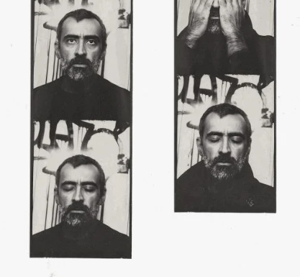
Nasri Sayegh
Flinders Street Photobooth Melbourne. Courtesy of the artist.

