Nasri Sayegh
Les Yeux Sans Visage (Eyes without a face), 2025
polyester, digital sublimate on silk georgette
Retinæ – 1, Retinæ – 2, Retinæ – 3, Retinæ – 4, 2025
tapestry, wool and cotton
Stitch it, black!, 2025
needlepoint on aida cloth with needle, wool, cotton, lurex, high carbon steel
Courtesy of the artist
Copyright © Nasri Sayegh

Commissioned by the Biennale of Sydney and Rubaiya Qatar, Qatar Museums Authority with generous assistance from Australian Tapestry Workshop and Weaver, David Pearce.

Education Resource (K-6)
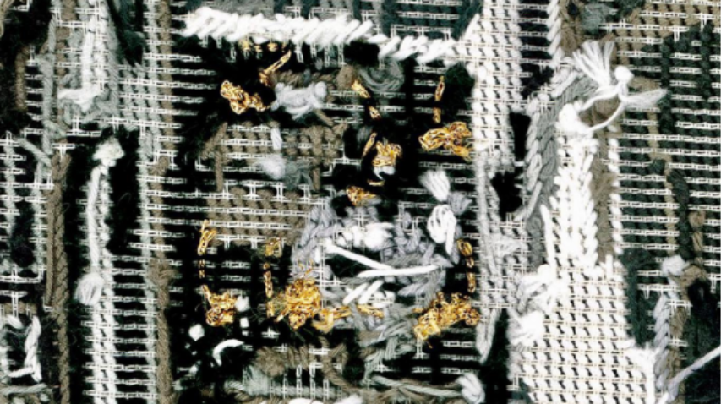
Memorial 1 / Fargo 1975, 2016
Photograph: Nasri Sayegh. Courtesy of the artist

Overview
Have you ever sewn a button back onto your favourite shirt, or watched someone stitch up a torn teddy bear? When we use needle and thread to fix something, we're making it whole again. Lebanese artist Nasri Sayegh uses embroidery, the art of stitching with needle and thread, to fix something much bigger: broken memories.
Nasri was born in Lebanon, a country that has experienced many years of war. War can damage buildings, homes, and also people's memories and feelings. When people lose their homes or loved ones, their memories can feel broken into pieces, like a torn photograph. Nasri collects old photographs from his life, such as pictures of family, places he's been, moments he remembers, and he cuts them up. Then he stitches them back together with embroidery thread, creating something new.
Look closely at his artworks. You'll see four tiny, delicate tapestries covered in careful stitches, one large embroidery, and a long piece of see-through fabric printed with stacked eyes that can move gently in the air. The eyes seem to be watching, remembering, witnessing what happened.
Each stitch Nasri makes is like a tiny act of healing. He shows us that the past isn't just something written in books. Our own stories are the strong threads that hold history together, turning broken pieces into a new, beautiful tapestry.

Je me souviens des montagnes, 2024
Photograph: Nasri Sayegh. Courtesy of the artist

Discussion Questions

Nasri uses stitching not just to join things together, but to show us that fixing something takes time, care, and gentleness.
What is going on in this artwork? Look closely at the lines made by the thread. Describe what they look like or might feel like to touch.
Why do you think the artist chose to sew instead of using tape or glue? What does sewing make you think of?

Usually, when we go to a gallery, we are the ones looking at the art. But in Nasri’s work, the art seems to be looking back at us.
How does it feel to stand in front of a piece of art that is looking at you? Why do you think the artist chose to place the eyes in this way?
Practical Activities
Activity 1

Sometimes, things that are precious to us can get broken, torn, or pulled apart, but being broken doesn't mean something is gone forever. This activity is all about the art of “mending”. Like how Nasri uses his photos to tell stories of healing, you are going to explore how fixing something can make it even more special than it was before.
To start you will need a paper, pencil, scissors and sticky tape.
Grab a piece of paper and draw a simple shape, like a heart, a star, or a circle.
Using scissors, cut out your shape from the paper.
Now, very carefully, tear it into a few pieces. You get to decide how it breaks; it might be one big snap right down the middle, or maybe it crumbles into lots of little islands.
Your mission is to be the "mender" and find a creative way to join your shape back together. Instead of trying to hide the rips, we want to show how we’ve fixed them.
You can draw dark stitching lines across the gaps to hold them tight, use tape to fix the spaces, or to create new patterns.
By the time you are finished, your paper won't just be a plain shape anymore, it will be a brand-new artwork that shows how strong and creative you can be when things need to be made whole again.

Activity 2

To help us understand how Nasri uses his work to keep stories alive, we first need to look closely at the patterns in the room.
A pattern is like a secret code of shapes and colours that repeat over and over, and in this space, those patterns are full of meaning.
Before you pick up your pencil, take a moment to explore the fabric around you with your detective eyes and think about these questions:
Does the pattern feel like it’s dancing and moving, or does it feel still and quiet?
Can you find any shapes that look like eyes, or perhaps shapes that look like they are guarding something?
If this pattern were a sound, would it be a loud drumbeat or a soft whisper?
Write a sentence for each on a page in your exercise book.

Now, imagine you are holding a very old, fragile photograph. If you leave it alone in a dark room, it might be forgotten. But if you and all your classmates look at it together, you are all looking it. Now, that memory lives in all of your minds at once.
By drawing a pattern of many eyes, the artist Nasri is making sure there are always enough watchers to keep the memory alive. It's like a circle of protection made from all our memories of looking at something.

On a new piece of paper, draw one large eye right in the centre of your page. This is the main watcher of your story.
Around it, draw five more eyes, but try to give each one a different feeling. You might make one look surprised with a very round pupil, one look sleepy with a heavy eyelid, or one look curious by pointing it toward the corner of the page.
Keep adding more eyes until you have built a strong, repeating pattern that fills a whole section of your book.
Once you feel your pattern is big enough, write one word underneath your pattern that describes what these eyes are protecting (e.g., family, love, stories).

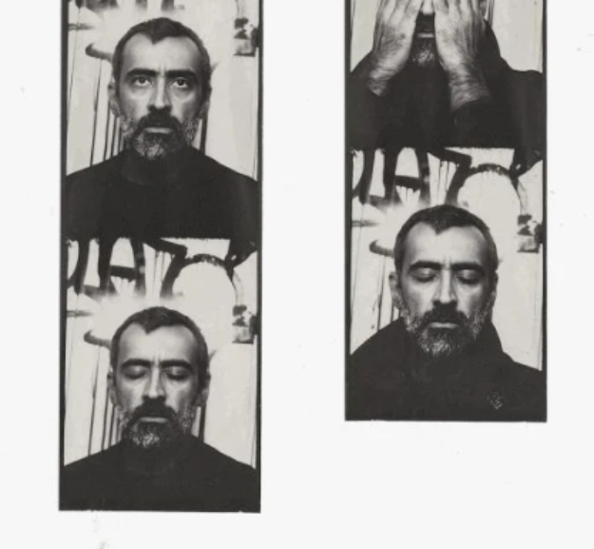
Nasri Sayegh
Flinders Street Photobooth Melbourne. Courtesy of the artist.

