Frank Young & The Kulata Tjuta Project
Kulata Tjuta: Rurrkuni, 2025
mulga, spearwood, mulga resin and kangaroo sinew

Commissioned by the Biennale of Sydney and the Fondation Cartier pour l'art contemporain
Courtesy of the artists and APY Art Centre Collective.
Copyright © Frank Young & The Kulata Tjuta Project

Education Resource (7-12)
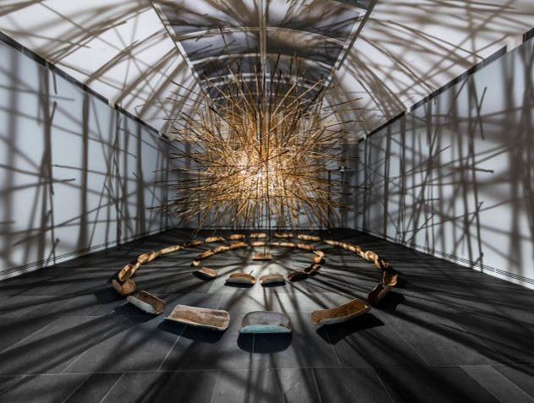
Kulata Tjuta, 2017,
Aṉangu Pitjantjatjara Yankunytjatjara Lands, South Australia,
Courtesy the artists and Ernabella Arts, Iwantja Arts, Kaltjiti Arts, Mimili Maku Arts, Ninuku Arts, Tjala Arts, Tjungu Palya
APY Art Centre Collective,
Art Gallery of South Australia, Adelaide,
Photo: Saul Steed

Overview
Frank Young’s practice within the Kuḻaṯa Tjuṯa (Many Spears) project functions as a monumental act of cultural maintenance and political agency on the APY Lands, asserting Aṉangu rights through the preservation of ancestral knowledge.
As the "last man standing" of the project’s original founders, Young facilitates a collaborative space where punu kulata (wooden spears) are crafted using materials such as resin and kangaroo tendons. This physical making is accompanied by ceremony and song, embedding spiritual practice into the object. Visually, Young’s work depicts memories of intersecting spears creating "dark clouds in the sky," evoking the concept of Tirkilpa the rattle of spears that signaled the onset of battle.
Young recontextualises this battle imagery as a contemporary struggle for cultural preservation and identity against the erosion of time. The act of making becomes a pedagogical tool, transferring agency from grandfather to grandson and ensuring the legacy of the senior artists who have passed away continues. By adhering to inherited fabrication methods and embedding the process with song, the work transcends being a static object and becomes a living vessel of Aṉangu law and resilience.

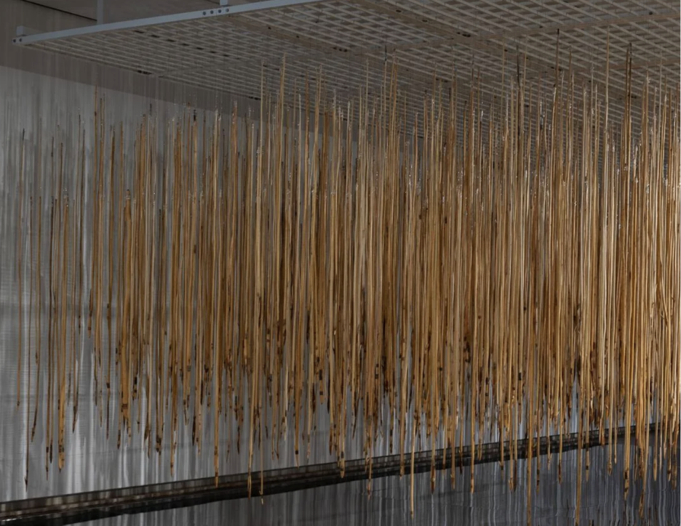Kulata Tjuta: Tirkilpa, installation view,
National Gallery of Australia, Kamberri/Canberra,
2025 © the artists, courtesy of APY Art Centre Collective.

Discussion Questions

Frank Young’s work is created during community camps where senior men teach younger men skills, songs, and ceremonies. The process of making is just as important as the finished installation.
Observe the materials (wood, resin, tendon). How does the strict adherence to ancestral techniques challenge the idea that modern art must use new technology?
How does this collaboration change the meaning of the work compared to if Frank Young had made it alone?
In Aṉangu history, the sound of Tirkilpa (rattling spears) signalled the start of a battle. Frank Young has recontextualised this symbol. It no longer represents a physical war, but a different kind of fight for Aṉangu rights and the survival of Aṉangu culture.
How does the Frank Young and tThe Kulata Tjuta Project use these visual qualities to create a feeling of tension or power for the audience?
By hanging hundreds of spears in an art gallery, how has the artist changed their function? Are they still weapons, or have they become something else?
How does the sheer volume of spears acts as a metaphor for the strength of the Aṉangu people today?

Practical Activities
Activity 1
Create a viewfinder with your hands and frame a section where the spears are most dense.
Ignore the details of the wood or the binding. We are looking for vectors (lines of force).
On your paper, map the dominant angles of the spears using strong, singular directional lines.
Identify where the lines converge. Mark these intersections with a heavier weight or a dark dot.
Observe the negative space (the gaps between the spears). Is the space trapped or flowing?
Quickly shade the negative space shapes in your drawing to emphasise the density of the objects.
Annotate the bottom of your sketch with one word that describes the tension.

Activity 2
Looking at the group of spears, select just one single spear that is close to you and identify a specific point where the materials meet, such as a binding, a knot, or a section of resin.
Create a detailed, close-up study of this connection point on your page. Fill at least half a page.
Focus entirely on the texture and the evidence of the human hand in the object.
Try to capture the specific way the tendon is wrapped or the uneven surface of the resin.
As you draw the binding, consider that this making process is accompanied by song and ceremony.
Once you have finished your sketch, write a few sentences speculating on the conversation held within this specific knot.
If the act of making is a pedagogical tool (a way of teaching), what lesson do you think was being taught while this specific section of the spear was being bound?
Connect your observation of the physical materials back to Frank Young’s goal of preserving Aṉangu law against the erosion of time.

