Frank Young & The Kulata Tjuta Project
Kulata Tjuta: Rurrkuni 2025
mulga, spearwood, mulga resin and kangaroo sinew
Commissioned by the Biennale of Sydney and the Fondation Cartier pour l'art contemporain
Courtesy of the artist and APY Art Centre Collective
© Frank Young & The Kulata Tjuta Project

Education Resource (K-6)
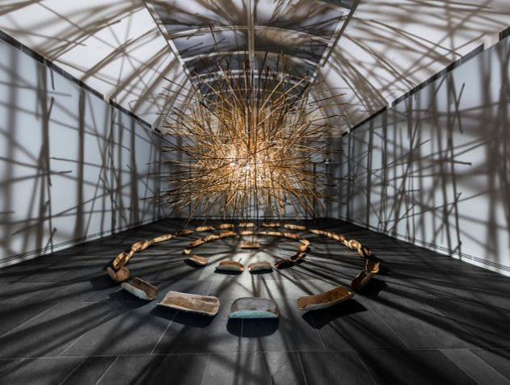
Kulata Tjuta, 2017
Aṉangu Pitjantjatjara Yankunytjatjara Lands, South Australia,
Courtesy the artists and Ernabella Arts, Iwantja Arts, Kaltjiti Arts, Mimili Maku Arts, Ninuku Arts, Tjala Arts, Tjungu Palya
APY Art Centre Collective,
Art Gallery of South Australia, Adelaide,

Overview
This artwork is a special way of keeping Aṉangu culture and history alive through the making of punu kulata (wooden spears). Frank Young is a senior First Nations artist from the APY Lands. This special place is a vast red desert in northern South Australia and is the Country of the Anangu people.
Frank Young, leads the Kuḻaṯa Tjuṯa (Many Spears) project. He works with young First Nations men to carve spears using materials found on the APY Lands, such as strong wood and sticky resin from grasses to bind them together. While they work, they use song and ceremony to help make the objects.
Frank shares a strong memory from when he was a little boy. He remembers seeing so many spears flying through the air that they looked like dark storm clouds. He calls the sound of these spears hitting together 'Tirkilpa'.
Long ago, this sound meant a battle was starting. Today, Frank is fighting a different kind of battle. He isn't fighting against people; he is fighting against forgetting. By teaching young men how to carve these spears, he is making sure their language and stories stay safe and are never lost.

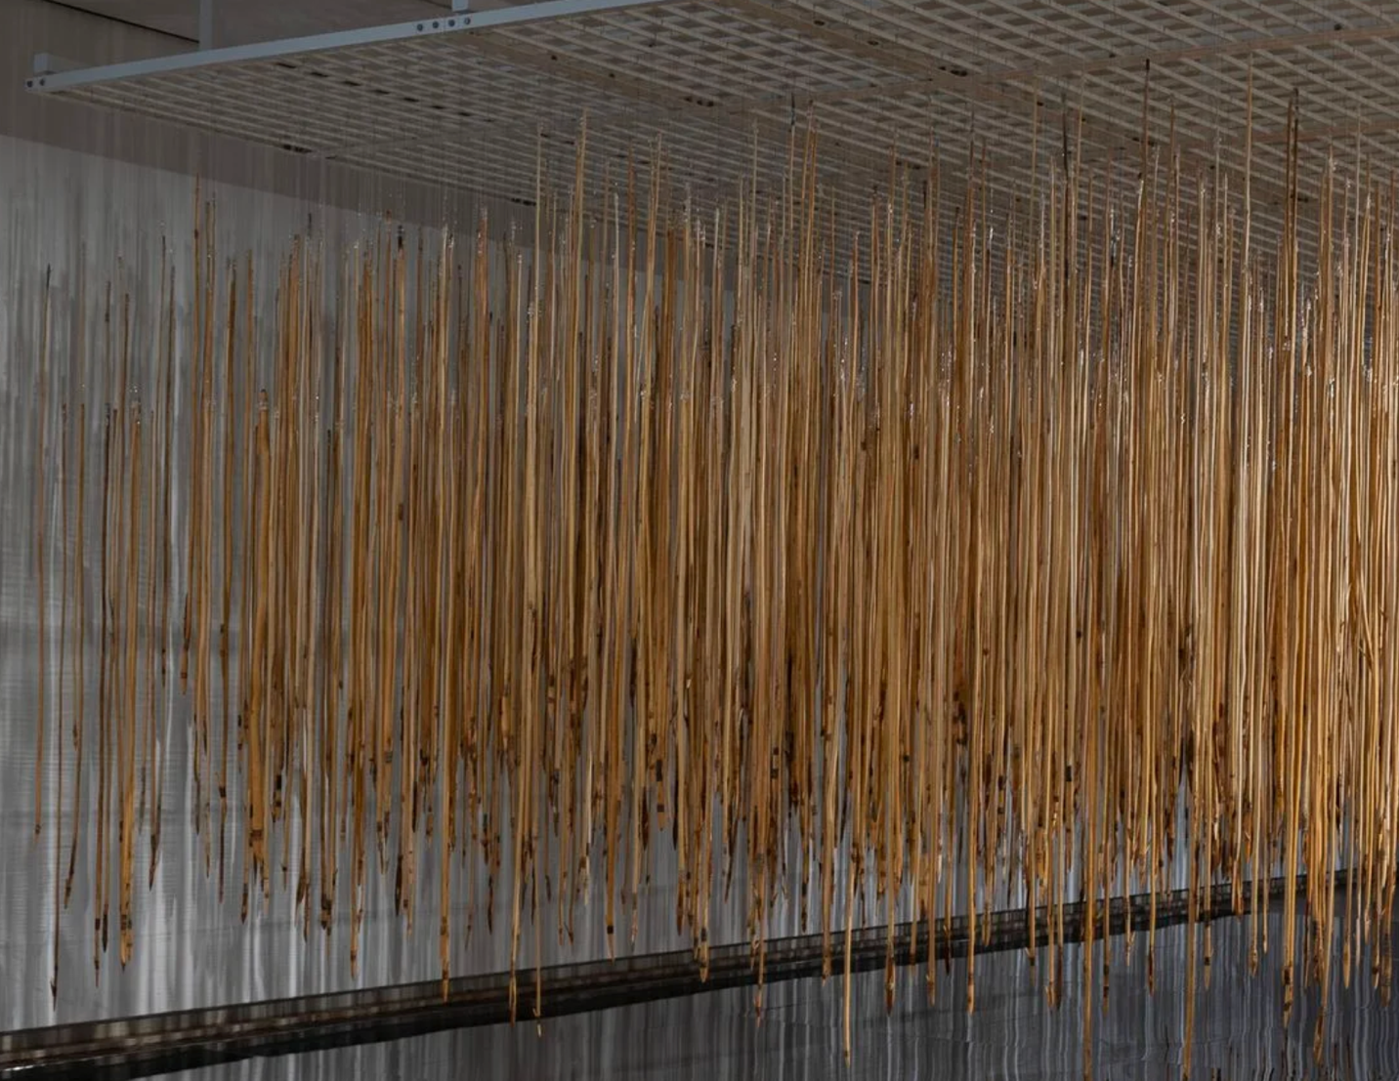Kulata Tjuta: Tirkilpa, installation view,
National Gallery of Australia, Kamberri/Canberra,
2025 © the artists, courtesy of APY Art Centre Collective.

Discussion Questions
Frank Young and his team of artists made these spears (punu kulata) using only things found on the APY Lands
Look closely at the spears. Can you see the different parts? Which part is the wood, and which part is the sticky grass glue holding it together?
Why do you think it was important for Frank Young to use materials found on his own Country instead of using materials that can be purchased at a shop? What does using the land tell us about Frank’s connection to it?
Imagine all these wooden spears bumping into each other. Frank calls that rattling sound Tirkilpa. If this artwork had a sound, would it be a quiet whisper or a loud crash?
In Aṉangu culture, important knowledge isn't just written in books. It is kept alive by being passed directly from Elders to young people.
Imagine you are one of the young boys working on this project. How would you feel knowing that the spear you are making is the same as the ones your ancestors made a long time ago?
Can you think of a skill or a story that a grandparent or older family member has taught you? Why is it important to remember it?

Practical Activities
Activity 1
Sit down comfortably in front of the installation and close your eyes for a moment.
Imagine the sound of Tirkilpa that Frank Young describes - the dry rattle of wooden spears hitting together.
Open your eyes and pick up your pencil. We are going to draw that sound.
If the sound feels sharp and loud to you, use fast, jagged, and zig-zag lines.
If the sound feels deep like a storm, use heavy, dark scribbles or thick swirling loops.
Fill your whole page with these marks until your paper looks as busy as the installation in front of you.
Hidden inside your drawing, write the word "Tirkilpa" three times in a style that matches your lines.

Activity 2

Frank Young uses the spear to represent skills taught to him by his grandfather.
Think of something important an older family member (like your mum, dad, or grandparent) has taught you.
It could be cooking, fishing, sewing, or even how to be kind.
In the middle of your page, draw one simple object that represents that special skill.
Now, just like Frank repeats the spear hundreds of times to show strength, draw your object 5 more times around the first one.
Connect them with a circle to show they are part of one story.
Underneath, write the name of the person who taught you this skill

