25th BIENNALE OF SYDNEY – Rememory | Educator-Led Tours
- General Tours – Showing students are shown up to eight works in language scaled to their age and ability
- Senior Case Study Tours – Showing students four works with a greater focus on construction and fabric methodology
For teachers opting for Senior Case Study Tours, please review the eight works below and nominate the four on which you would like our Educators to focus.
Artist | Title | Notes
Dennis Golding | Connecting Back, 2026 | Dennis Golding is a Kamilaroi/Gamilaraay artist whose new work for the 25th Biennale of Sydney offers a poignant exploration of history, memory, and community resilience. Focusing on the legacy & gentrification of 'The Block' in Redfern —a significant site of Aboriginal activism and community in Sydney — Golding has designed a large-scale interactive sculpture.  The work reimagines a childhood toy usually found in doctor’s waiting rooms by replacing standard blocks with replica ceramic bricks from Redfern’s iconic, now-demolished Aboriginal Flag mural.
Marian Abboud | Sister +++++ Familial Formations III, 2026 | Marian Abboud is a multi-disciplinary artist based in Western Sydney whose practice utilises diverse technologies to foster collective outcomes and social activism. Integrating images (featuring four generations of Marian’s relatives), video, sound, and text, Abboud’s artwork is centred around her father’s 1964 Isuzu Bellett.  The work offers a profound entry point for students to explore complex narratives surrounding loss, family dynamics, death, and cultural rituals.
Gunybi Ganambarr | Mundatjŋu  Ŋaymil font  Dhuwa spring | Gunybi Ganambarr is a leading Australian contemporary artist recognized for driving innovation within the historically strict Yolŋu art traditions of North East Arnhem Land. The evolution of his practice began with elaborately carved ceremonial poles and bark paintings before expanding into groundbreaking new mediums. Around 2013, Ganambarr pioneered the ‘found’ movement of Yolŋu art by reclaiming industrial detritus from mine sites on his Country. By incising discarded conveyor belts and sheet metal with minytji (sacred designs) belonging to his Ŋaymil clan, his work offers a profound entry point for classroom discussions on environmental impact, the collision of industry and tradition, and the resilience of First Nations cultural expression. The works depict sacred freshwater systems, such as Balawurru, a spiritually potent spring where Brolga and sacred goanna dance and swim, shaping the water’s surface with their movements.

Dennis Golding | Marian Abboud | Gunybi Ganambarr

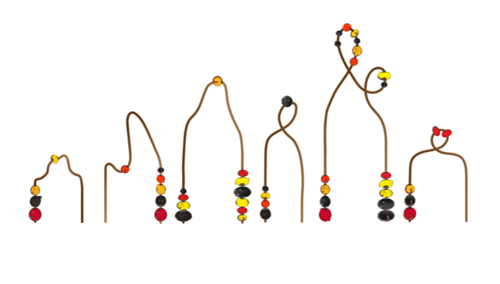  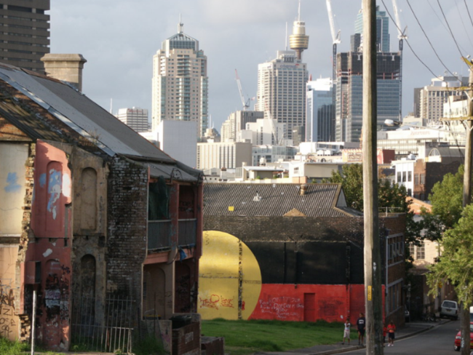 | 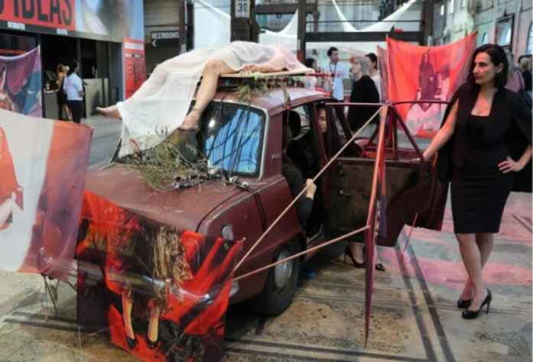 | 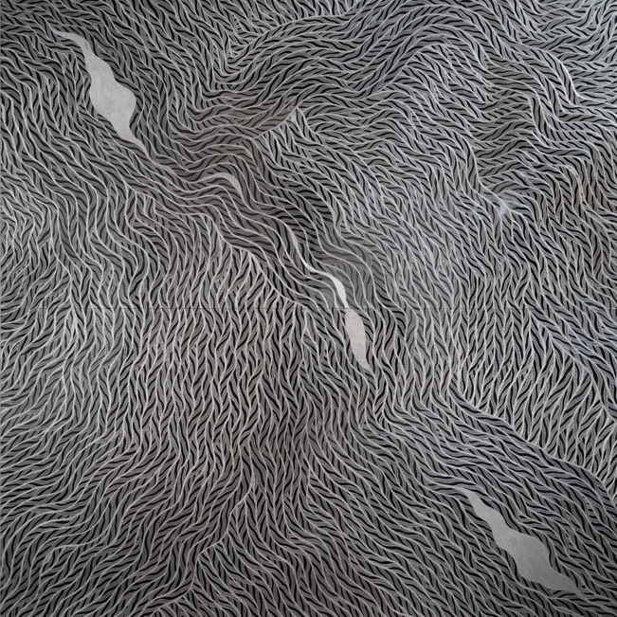

Nancy YUKUWAL McDinny | Jurlayarriyarri (Morning Glory), 2025 | Nancy Yukuwal McDinny’s practice offers a vital entry point for students to engage with both the rich cultural traditions and the complex, often silenced histories of the gulf region in the North of Australia. Her paintings frequently celebrate cultural continuity through stories of hunting, collecting bush tucker, and traveling to visit kin.  However, McDinny also uses her art to boldly confront the brutal realities of European settlement experienced by her family and the ongoing environmental devastation caused by mining — two forces she views as intrinsically connected. For the 25th Biennale of Sydney, visitors will encounter her largest work to date: a monumental diptych painting that serves as a powerful catalyst for discussions around truth-telling, environmental stewardship, and first nations resilience.
Tania Willard | Forest Glass, 2026 | Tania Willard is an Secwépemc and settler Canadian artist and curator whose practice occupies the vital intersection of research and land-based art. By centring art as an act of Indigenous resurgence, her collaborative and interactive projects are designed to actively connect audiences to land, culture, and family. Willard has produced a custom stained-glass effect that interacts directly with the building's unique industrial architecture and its iconic windows.  Using green-tinted Perspex and timber panels, the work evokes uranium glass and toxic spills while drawing connections between industrialisation, invasive species, and the ecological violence of colonisation. This vibrant work provides an excellent opportunity for students to explore how contemporary Indigenous art can converse with historical spaces to elevate cultural narratives.
Ángel Poyón | The hand, the foot of our brooms, The hand, the foot of our hoe / our hoes, 2025 | For Ángel Poyón art is not just about creation but about finding the spirit within an object and honouring the profound union between a tool and the person who uses it. Visitors will encounter a powerful installation of 80 hand-carved sculptures, comprising 40 shovels and 40 brooms, each featuring a handle that transforms into a clenched fist.  Assembled to honour the labour and resistance of farmers, these modified tools give voice to the earth itself, demanding respect for both the land and the hands that tend to it. His practice explores art's potential to "awaken" cultural memory and wisdom embedded in daily tools, land, and materials.
Nancy McDinny | Tania Willard | Ángel Poyón

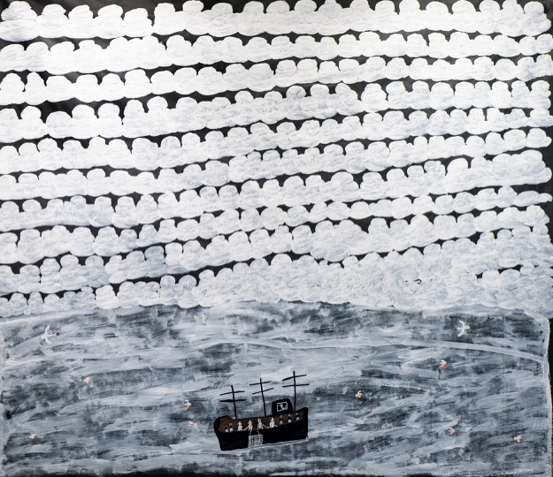 | 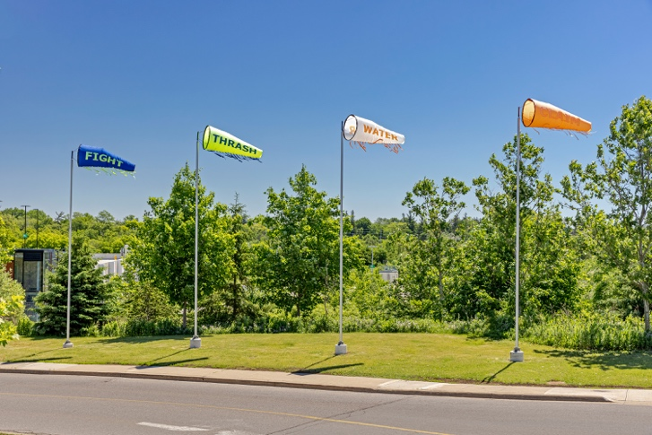 | 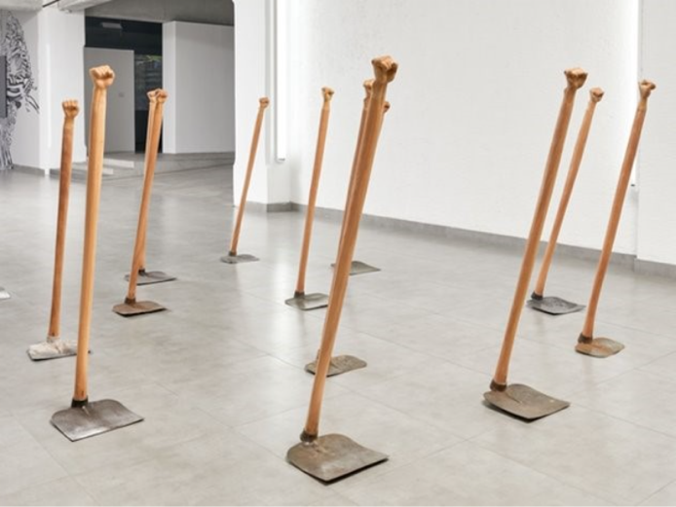

Carmen Glynn-Braun | To hold the line of 'Ware' (fire), 2026 | Carmen Glynn-Braun is a Kaytetye, Anmatyerr and Arrernte artist who lives and works between Sydney and Mparntwe (Alice Springs). Her research-driven practice frequently centres on public art and the creation of community spaces. As a member of the Re-Right Collective, alongside Dennis Golding, her contribution to the 25th Biennale of Sydney transforms a section of the White Bay Power Station into a dedicated site for knowledge sharing.  Her new multimedia installation serves as a profound tribute to the women makers of her Country. The artwork grounds digital storytelling in the earth by projecting animated stories directly onto soil, framed by shards of handcrafted pottery. Together, these natural and crafted materials symbolise the fragmentation of history, functioning as a powerful educational touchpoint about cultural memories that are both held and lost.
Nikesha Breeze | Living Histories, 2026 | Nikesha Breeze is an interdisciplinary artist whose practice is deeply rooted in a global African diasporic and Afro-Futurist perspective. Utilising a wide array of mediums, Breeze creates otherworldly spaces dedicated to reclamation and honouring. For the 25th Biennale of Sydney, Breeze is presenting their most ambitious work to date. This monumental installation explores the first-hand accounts of those who lived through the height of the Atlantic slave trade.  By amplifying these archival voices, the artwork serves as a powerful educational touchpoint for discussing historical resilience, the enduring impacts of the diaspora, and the importance of reclaiming erased narratives. Their work offers a profound entry point for students to reimagine relationships with the human body, the invisible world, and shared social spaces.

Nikesha Breeze | Carmen Glynn-Braun
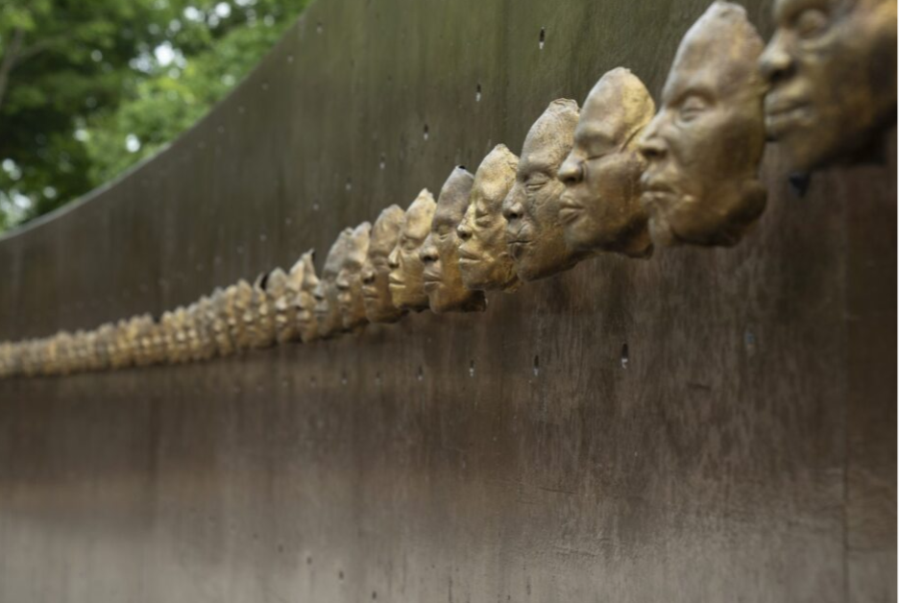 | 